Multiple choice section – choose the correct answer

Question 1 [6.1]

For the triangle shown, is equivalent to:

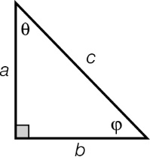

A  B  C  D 

Question 2 [6.1]

The angle 35.28° + is closest to:

A 60.46° B 61.23° C 60.74 D 60.58°

Question 3 [6.2]

The value of *y* is:

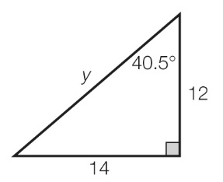

A 23.0 B 27.1 C 25.2 D 18.44

Question 4 [6.2]

A mine shaft 120 m long is dug at an angle of 25°50′ to the vertical. In metres, how far down will the end of the shaft be?

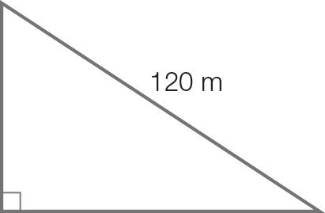

A 108.01 B 95.67 C 50.73 D 58.76

Question 5 [6.3]

The value of θ in degrees and minutes is:

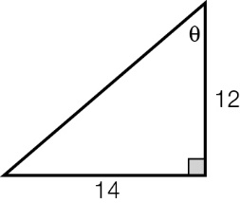

A 40°36′ B 42°48′ C 49°24′ D 37°16′

Question 6 [6.4]

The angle of elevation of the top of a tree from a point on the ground 22 m away is 24°. The height of the tree in metres is:

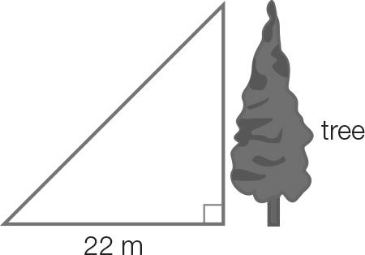

A 20.10 B 8.95 C 24.08 D 9.80

Question 7 [6.5]

An aircraft leaves the airport and flies 73 km on a bearing S30°E. It then heads due north until it is due east of the airport. How far, in km, from the airport is the aircraft?

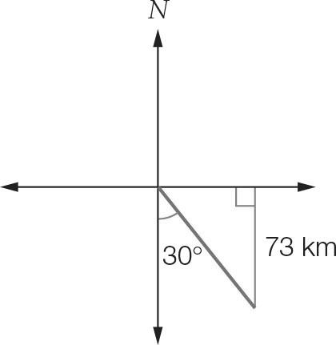

A 63.2 km B 36.5 km C 126.4 km D 43.9 km

Question 8 [6.5]

The angle θ is measured clockwise from north. If sin(θ) = 0.5, then the compass bearing is:

A N30°E B N60°E C 060°T D 030°T

Multiple-choice total marks: 8

Short answer section

Question 9 2 marks [6.2]

Calculate the values of *x* and *y*, correct to 2 decimal places.

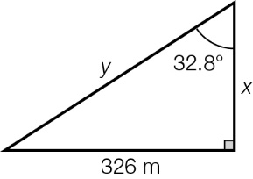

Question 10 2 marks [6.3]

Two kites are flown as shown. Find the angles α and θ that the strings make with the ground, expressed in degrees and minutes.

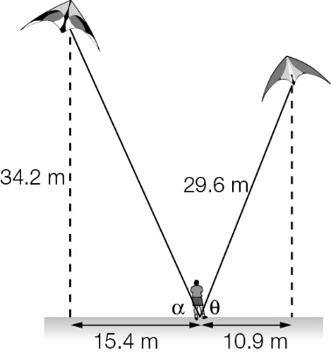

Question 11 3 marks [6.4]

Jay climbed a tree to a height of 9.25 m above the ground. His dog runs away from the base of the tree at 8 m/s. Find the angle of depression in degrees and minutes from Jay to his dog after 2 seconds.

Question 12 3 marks [6.4]

Milos is standing 5.21 m in front of a flagpole 6.45 m high. The vertical distance from the top of Milos’ head to the top of the flagpole is 5.83 m and his eyes are 15 cm below the top of his head. What angle of elevation must Milos look up at to see the top of the flagpole? Give your answer to the nearest degree.

Question 13 4 marks [6.6]

An ant walks from point A to point B and then to point C.

(a) What is the true bearing of point B from point A, correct to 2 decimal places?

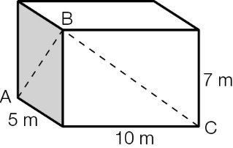

(b) How far did the ant walk to get from B to C, correct to 2 decimal places?

Short answer total marks: 14

Extended response section

Question 14 6 marks [6.6]

Lights attached to two cables are strung through two trees. The first cable makes an angle of 36.24° from the ground to the first tree. The second cable makes an angle of 65° from first tree to the second tree, as shown in the diagram. (There is no cable along the ground.) Find the length of the cable to the nearest centimetre.

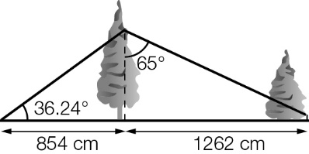

Question 15 5 marks [6.5]

An aircraft leaves the airport and flies 84 km on a bearing of 060°T. The aircraft then turns clockwise 90° and flies a further 13 km before flying directly back to the airport.

(a) What was the total length of the flight?

(b) What is the bearing from the airport to the end of the second part of the flight? Give your answer to 2 decimal places.

Extended answer total marks: 11

TOTAL test marks: 33